Міністерство освіти і науки України

Національний технічний університет України

«Київський політехнічний інститут»

Лабораторна робота №4

**«КОМПЛЕКСНЕ ВИКОРИСТАННЯ ЗАСОБІВ ВЗАЄМОДІЇ**

**ПАРАЛЕЛЬНИХ ПОТОКІВ ОПЕРАЦІЙНОЇ СИСТЕМИ LINUX»**

Виконав студент групи: КВ-22

Землянський Едуард

**Київ 2024**

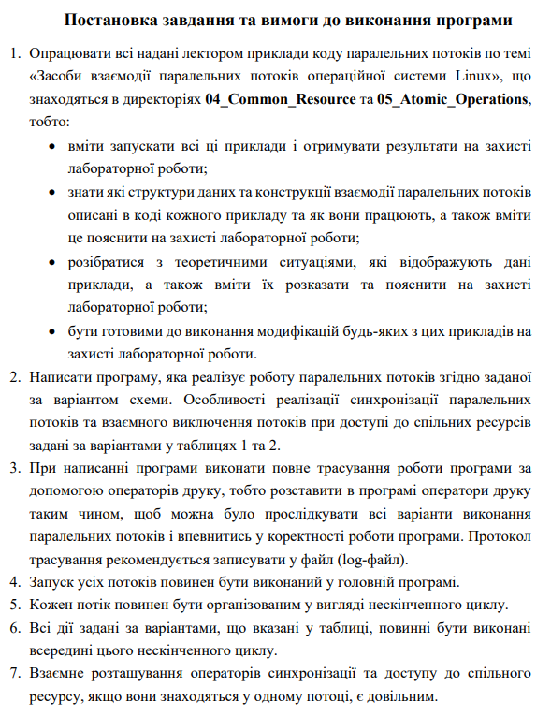

**Варіант завдання №7**

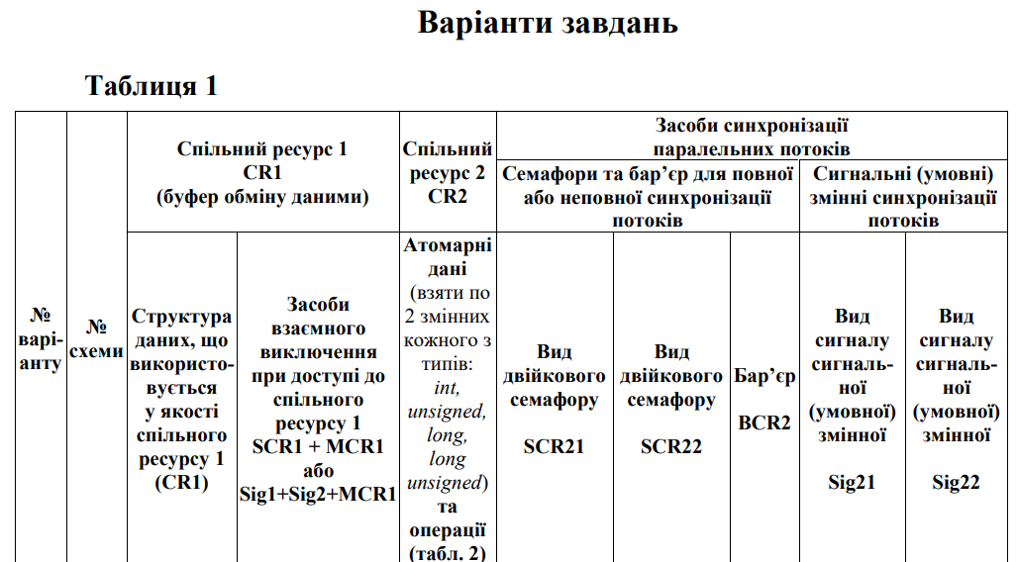

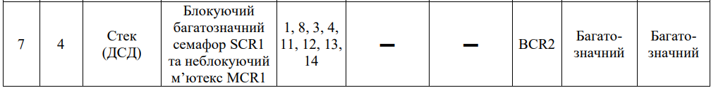

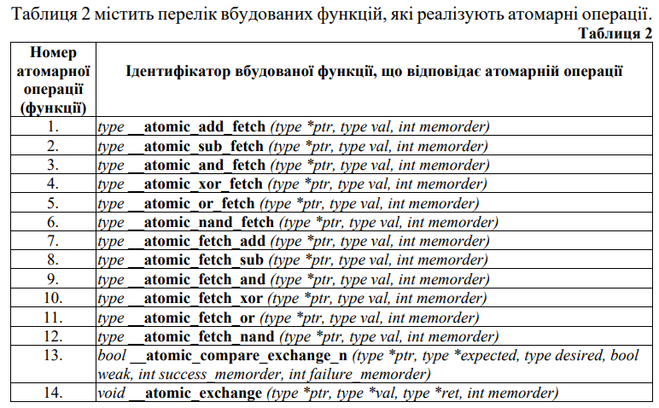

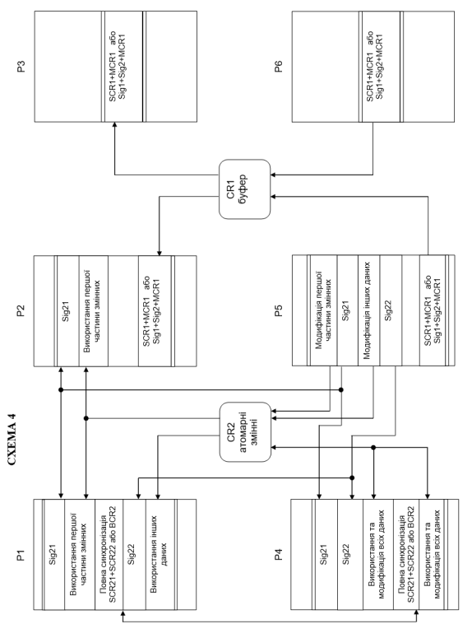

**Результати виконання програми**

**Пуск1**

P1 waiting for Sig21

P2 waiting for Sig21

P5 sent Sig21 for P1

P5 sent Sig21 for P4

P5 sent Sig22 for P1

P5 sent Sig22 for P4

P5 (Producer) write 0 to CR1[10]. Semaphore: 0

P5 sent Sig21 for P1

P5 sent Sig21 for P4

P5 sent Sig22 for P1

P5 sent Sig22 for P4

P5 (Producer) write 1 to CR1[11]. Semaphore: 1

P5 sent Sig21 for P1

P5 sent Sig21 for P4

P5 sent Sig22 for P1

P5 sent Sig22 for P4

P5 (Producer) write 4 to CR1[12]. Semaphore: 2

P5 sent Sig21 for P1

P5 sent Sig21 for P4

P5 sent Sig22 for P1

P5 sent Sig22 for P4

P5 (Producer) write 5 to CR1[13]. Semaphore: 3

P5 sent Sig21 for P1

P5 sent Sig21 for P4

P5 sent Sig22 for P1

P5 sent Sig22 for P4

P5 (Producer) write 0 to CR1[14]. Semaphore: 4

P5 sent Sig21 for P1

P5 sent Sig21 for P4

P5 sent Sig22 for P1

P5 sent Sig22 for P4

P5 (Producer) write 5 to CR1[15]. Semaphore: 5

P5 sent Sig21 for P1

P5 sent Sig21 for P4

P5 sent Sig22 for P1

P5 sent Sig22 for P4

P5 (Producer) write 4 to CR1[16]. Semaphore: 6

P5 sent Sig21 for P1

P5 sent Sig21 for P4

P5 sent Sig22 for P1

P5 sent Sig22 for P4

P5 (Producer) write 0 to CR1[17]. Semaphore: 7

P5 sent Sig21 for P1

P5 sent Sig21 for P4

P5 sent Sig22 for P1

P5 sent Sig22 for P4

P5 (Producer) write 0 to CR1[18]. Semaphore: 8

P5 sent Sig21 for P1

P5 sent Sig21 for P4

P5 sent Sig22 for P1

P5 sent Sig22 for P4

P5 (Producer) write 5 to CR1[19]. Semaphore: 9

P5 sent Sig21 for P1

P5 sent Sig21 for P4

P5 sent Sig22 for P1

P5 sent Sig22 for P4

P5 (Producer) write 2 to CR1[20]. Semaphore: 10

P5 sent Sig21 for P1

P5 sent Sig21 for P4

P5 sent Sig22 for P1

P5 sent Sig22 for P4

P5 (Producer) write 9 to CR1[21]. Semaphore: 11

P5 sent Sig21 for P1

P5 sent Sig21 for P4

P5 sent Sig22 for P1

P5 sent Sig22 for P4

P5 (Producer) write 1 to CR1[22]. Semaphore: 12

P5 sent Sig21 for P1

P5 sent Sig21 for P4

P5 sent Sig22 for P1

P5 sent Sig22 for P4

P5 (Producer) write 4 to CR1[23]. Semaphore: 13

P5 sent Sig21 for P1

P5 sent Sig21 for P4

P5 sent Sig22 for P1

P5 sent Sig22 for P4

P5 (Producer) write 2 to CR1[24]. Semaphore: 14

P5 sent Sig21 for P1

P5 sent Sig21 for P4

P5 sent Sig22 for P1

P5 sent Sig22 for P4

P5 (Producer) write 1 to CR1[25]. Semaphore: 15

P5 sent Sig21 for P1

P5 sent Sig21 for P4

P5 sent Sig22 for P1

P5 sent Sig22 for P4

P5 (Producer) write 4 to CR1[26]. Semaphore: 16

P5 sent Sig21 for P1

P5 sent Sig21 for P4

P5 sent Sig22 for P1

P5 sent Sig22 for P4

P5 (Producer) write 4 to CR1[27]. Semaphore: 17

P5 sent Sig21 for P1

P5 sent Sig21 for P4

P5 sent Sig22 for P1

P5 sent Sig22 for P4

P5 (Producer) write 2 to CR1[28]. Semaphore: 18

P5 sent Sig21 for P1

P5 sent Sig21 for P4

P5 sent Sig22 for P1

P5 sent Sig22 for P4

P5 (Producer) write 5 to CR1[29]. Semaphore: 19

P2 waiting for Sig21

P1 used atomic

P3 (Consumer) took 5 from CR1[28]. Semaphore value: 19

P3 (Consumer) took 2 from CR1[27]. Semaphore value: 18

P3 (Consumer) took 4 from CR1[26]. Semaphore value: 17

P3 (Consumer) took 4 from CR1[25]. Semaphore value: 16

P3 (Consumer) took 1 from CR1[24]. Semaphore value: 15

P3 (Consumer) took 2 from CR1[23]. Semaphore value: 14

P3 (Consumer) took 4 from CR1[22]. Semaphore value: 13

P3 (Consumer) took 1 from CR1[21]. Semaphore value: 12

P3 (Consumer) took 9 from CR1[20]. Semaphore value: 11

P3 (Consumer) took 2 from CR1[19]. Semaphore value: 10

P3 (Consumer) took 5 from CR1[18]. Semaphore value: 9

P3 (Consumer) took 0 from CR1[17]. Semaphore value: 8

P3 (Consumer) took 0 from CR1[16]. Semaphore value: 7

P3 (Consumer) took 4 from CR1[15]. Semaphore value: 6

P3 (Consumer) took 5 from CR1[14]. Semaphore value: 5

P3 (Consumer) took 0 from CR1[13]. Semaphore value: 4

P3 (Consumer) took 5 from CR1[12]. Semaphore value: 3

P3 (Consumer) took 4 from CR1[11]. Semaphore value: 2

P3 (Consumer) took 1 from CR1[10]. Semaphore value: 1

P3 (Consumer) took 0 from CR1[9]. Semaphore value: 0

P5 stop all threads and program!P6 (Producer) write 5 to CR1[10]. Semaphore: 0

P6 (Producer) write 0 to CR1[11]. Semaphore: 1

P6 (Producer) write 6 to CR1[12]. Semaphore: 2

P6 (Producer) write 4 to CR1[13]. Semaphore: 3

P6 (Producer) write 0 to CR1[14]. Semaphore: 4

P6 (Producer) write 7 to CR1[15]. Semaphore: 5

P6 (Producer) write 8 to CR1[16]. Semaphore: 6

P6 (Producer) write 0 to CR1[17]. Semaphore: 7

P6 (Producer) write 7 to CR1[18]. Semaphore: 8

P6 (Producer) write 9 to CR1[19]. Semaphore: 9

P6 (Producer) write 8 to CR1[20]. Semaphore: 10

P6 (Producer) write 9 to CR1[21]. Semaphore: 11

P6 (Producer) write 0 to CR1[22]. Semaphore: 12

P6 (Producer) write 4 to CR1[23]. Semaphore: 13

P6 (Producer) write 4 to CR1[24]. Semaphore: 14

P6 (Producer) write 2 to CR1[25]. Semaphore: 15

P6 (Producer) write 9 to CR1[26]. Semaphore: 16

P6 (Producer) write 0 to CR1[27]. Semaphore: 17

P6 (Producer) write 3 to CR1[28]. Semaphore: 18

P6 (Producer) write 0 to CR1[29]. Semaphore: 19

P6 stop all threads and program!

**Пуск2**

P1 waiting for Sig21

P2 waiting for Sig21

P4 waiting for Sig21

P5 sent Sig21 for P1

P5 sent Sig21 for P4

P1 used atomic

P5 sent Sig22 for P1

P5 sent Sig22 for P4

P5 (Producer) write 8 to CR1[10]. Semaphore: 0

P5 sent Sig21 for P1

P5 sent Sig21 for P4

P5 sent Sig22 for P1

P5 sent Sig22 for P4

P5 (Producer) write 6 to CR1[11]. Semaphore: 1

P5 sent Sig21 for P1

P5 sent Sig21 for P4

P5 sent Sig22 for P1

P5 sent Sig22 for P4

P5 (Producer) write 1 to CR1[12]. Semaphore: 2

P5 sent Sig21 for P1

P5 sent Sig21 for P4

P5 sent Sig22 for P1

P5 sent Sig22 for P4

P5 (Producer) write 1 to CR1[13]. Semaphore: 3

P5 sent Sig21 for P1

P5 sent Sig21 for P4

P5 sent Sig22 for P1

P5 sent Sig22 for P4

P5 (Producer) write 3 to CR1[14]. Semaphore: 4

P5 sent Sig21 for P1

P5 sent Sig21 for P4

P5 sent Sig22 for P1

P5 sent Sig22 for P4

P5 (Producer) write 8 to CR1[15]. Semaphore: 5

P5 sent Sig21 for P1

P5 sent Sig21 for P4

P5 sent Sig22 for P1

P5 sent Sig22 for P4

P5 (Producer) write 3 to CR1[16]. Semaphore: 6

P5 sent Sig21 for P1

P5 sent Sig21 for P4

P5 sent Sig22 for P1

P5 sent Sig22 for P4

P5 (Producer) write 5 to CR1[17]. Semaphore: 7

P5 sent Sig21 for P1

P5 sent Sig21 for P4

P5 sent Sig22 for P1

P5 sent Sig22 for P4

P5 (Producer) write 5 to CR1[18]. Semaphore: 8

P5 sent Sig21 for P1

P5 sent Sig21 for P4

P5 sent Sig22 for P1

P5 sent Sig22 for P4

P5 (Producer) write 4 to CR1[19]. Semaphore: 9

P5 sent Sig21 for P1

P5 sent Sig21 for P4

P5 sent Sig22 for P1

P5 sent Sig22 for P4

P5 (Producer) write 7 to CR1[20]. Semaphore: 10

P5 sent Sig21 for P1

P5 sent Sig21 for P4

P5 sent Sig22 for P1

P5 sent Sig22 for P4

P5 (Producer) write 4 to CR1[21]. Semaphore: 11

P5 sent Sig21 for P1

P5 sent Sig21 for P4

P5 sent Sig22 for P1

P5 sent Sig22 for P4

P5 (Producer) write 3 to CR1[22]. Semaphore: 12

P5 sent Sig21 for P1

P5 sent Sig21 for P4

P5 sent Sig22 for P1

P5 sent Sig22 for P4

P5 (Producer) write 0 to CR1[23]. Semaphore: 13

P5 sent Sig21 for P1

P5 sent Sig21 for P4

P5 sent Sig22 for P1

P5 sent Sig22 for P4

P5 (Producer) write 3 to CR1[24]. Semaphore: 14

P5 sent Sig21 for P1

P5 sent Sig21 for P4

P5 sent Sig22 for P1

P5 sent Sig22 for P4

P5 (Producer) write 3 to CR1[25]. Semaphore: 15

P5 sent Sig21 for P1

P5 sent Sig21 for P4

P5 sent Sig22 for P1

P5 sent Sig22 for P4

P5 (Producer) write 5 to CR1[26]. Semaphore: 16

P5 sent Sig21 for P1

P5 sent Sig21 for P4

P5 sent Sig22 for P1

P5 sent Sig22 for P4

P5 (Producer) write 2 to CR1[27]. Semaphore: 17

P5 sent Sig21 for P1

P5 sent Sig21 for P4

P5 sent Sig22 for P1

P5 sent Sig22 for P4

P5 (Producer) write 8 to CR1[28]. Semaphore: 18

P5 sent Sig21 for P1

P5 sent Sig21 for P4

P5 sent Sig22 for P1

P5 sent Sig22 for P4

P5 (Producer) write 8 to CR1[29]. Semaphore: 19

P4 used atomic

P4 modify all atomic

P4 used atomic

P4 modify all atomic

P1 used atomic

P2 waiting for Sig21

P3 (Consumer) took 8 from CR1[28]. Semaphore value: 19

P3 (Consumer) took 8 from CR1[27]. Semaphore value: 18

P3 (Consumer) took 2 from CR1[26]. Semaphore value: 17

P3 (Consumer) took 5 from CR1[25]. Semaphore value: 16

P3 (Consumer) took 3 from CR1[24]. Semaphore value: 15

P3 (Consumer) took 3 from CR1[23]. Semaphore value: 14

P3 (Consumer) took 0 from CR1[22]. Semaphore value: 13

P3 (Consumer) took 3 from CR1[21]. Semaphore value: 12

P3 (Consumer) took 4 from CR1[20]. Semaphore value: 11

P3 (Consumer) took 7 from CR1[19]. Semaphore value: 10

P3 (Consumer) took 4 from CR1[18]. Semaphore value: 9

P3 (Consumer) took 5 from CR1[17]. Semaphore value: 8

P3 (Consumer) took 5 from CR1[16]. Semaphore value: 7

P3 (Consumer) took 3 from CR1[15]. Semaphore value: 6

P3 (Consumer) took 8 from CR1[14]. Semaphore value: 5

P3 (Consumer) took 3 from CR1[13]. Semaphore value: 4

P3 (Consumer) took 1 from CR1[12]. Semaphore value: 3

P3 (Consumer) took 1 from CR1[11]. Semaphore value: 2

P3 (Consumer) took 6 from CR1[10]. Semaphore value: 1

P3 (Consumer) took 8 from CR1[9]. Semaphore value: 0

P6 (Producer) write 7 to CR1[10]. Semaphore: 0

P3 (Consumer) took 7 from CR1[9]. Semaphore value: 0

P6 (Producer) write 2 to CR1[10]. Semaphore: 0

P3 (Consumer) took 2 from CR1[9]. Semaphore value: 0

P6 (Producer) write 8 to CR1[10]. Semaphore: 0

P3 (Consumer) took 8 from CR1[9]. Semaphore value: 0

P6 (Producer) write 9 to CR1[10]. Semaphore: 0

P3 (Consumer) took 9 from CR1[9]. Semaphore value: 0

P6 (Producer) write 0 to CR1[10]. Semaphore: 0

P3 (Consumer) took 0 from CR1[9]. Semaphore value: 0

P6 (Producer) write 3 to CR1[10]. Semaphore: 0

P3 (Consumer) took 3 from CR1[9]. Semaphore value: 0

P6 (Producer) write 1 to CR1[10]. Semaphore: 0

P3 (Consumer) took 1 from CR1[9]. Semaphore value: 0

P6 (Producer) write 2 to CR1[10]. Semaphore: 0

P3 (Consumer) took 2 from CR1[9]. Semaphore value: 0

P6 (Producer) write 1 to CR1[10]. Semaphore: 0

P3 (Consumer) took 1 from CR1[9]. Semaphore value: 0

P6 (Producer) write 0 to CR1[10]. Semaphore: 0

P3 (Consumer) took 0 from CR1[9]. Semaphore value: 0

P6 (Producer) write 4 to CR1[10]. Semaphore: 0

P3 (Consumer) took 4 from CR1[9]. Semaphore value: 0

P6 (Producer) write 1 to CR1[10]. Semaphore: 0

P3 (Consumer) took 1 from CR1[9]. Semaphore value: 0

P6 (Producer) write 6 to CR1[10]. Semaphore: 0

P3 (Consumer) took 6 from CR1[9]. Semaphore value: 0

P6 (Producer) write 6 to CR1[10]. Semaphore: 0

P3 (Consumer) took 6 from CR1[9]. Semaphore value: 0

P6 (Producer) write 4 to CR1[10]. Semaphore: 0

P6 (Producer) write 2 to CR1[11]. Semaphore: 1

P6 (Producer) write 4 to CR1[12]. Semaphore: 2

P6 (Producer) write 7 to CR1[13]. Semaphore: 3

P6 (Producer) write 7 to CR1[14]. Semaphore: 4

P6 (Producer) write 9 to CR1[15]. Semaphore: 5

P6 (Producer) write 1 to CR1[16]. Semaphore: 6

P6 (Producer) write 4 to CR1[17]. Semaphore: 7

P6 (Producer) write 6 to CR1[18]. Semaphore: 8

P6 (Producer) write 7 to CR1[19]. Semaphore: 9

P6 (Producer) write 6 to CR1[20]. Semaphore: 10

P6 (Producer) write 9 to CR1[21]. Semaphore: 11

P6 (Producer) write 0 to CR1[22]. Semaphore: 12

P6 (Producer) write 1 to CR1[23]. Semaphore: 13

P6 (Producer) write 3 to CR1[24]. Semaphore: 14

P6 (Producer) write 0 to CR1[25]. Semaphore: 15

P6 (Producer) write 0 to CR1[26]. Semaphore: 16

P6 (Producer) write 1 to CR1[27]. Semaphore: 17

P6 (Producer) write 4 to CR1[28]. Semaphore: 18

P6 (Producer) write 0 to CR1[29]. Semaphore: 19

P3 (Consumer) took 0 from CR1[28]. Semaphore value: 19

P3 (Consumer) took 4 from CR1[27]. Semaphore value: 18

P3 (Consumer) took 1 from CR1[26]. Semaphore value: 17

P3 (Consumer) took 0 from CR1[25]. Semaphore value: 16

P3 (Consumer) took 0 from CR1[24]. Semaphore value: 15

P3 (Consumer) took 3 from CR1[23]. Semaphore value: 14

P3 (Consumer) took 1 from CR1[22]. Semaphore value: 13

P3 (Consumer) took 0 from CR1[21]. Semaphore value: 12

P3 (Consumer) took 9 from CR1[20]. Semaphore value: 11

P3 (Consumer) took 6 from CR1[19]. Semaphore value: 10

P3 (Consumer) took 7 from CR1[18]. Semaphore value: 9

P3 (Consumer) took 6 from CR1[17]. Semaphore value: 8

P3 (Consumer) took 4 from CR1[16]. Semaphore value: 7

P3 (Consumer) took 1 from CR1[15]. Semaphore value: 6

P3 (Consumer) took 9 from CR1[14]. Semaphore value: 5

P3 (Consumer) took 7 from CR1[13]. Semaphore value: 4

P3 (Consumer) took 7 from CR1[12]. Semaphore value: 3

P3 (Consumer) took 4 from CR1[11]. Semaphore value: 2

P3 (Consumer) took 2 from CR1[10]. Semaphore value: 1

P3 (Consumer) took 4 from CR1[9]. Semaphore value: 0

P5 stop all threads and program!